Step 1: Click on “ Your VPC” on the left side (or you can use VPC Wizard too)

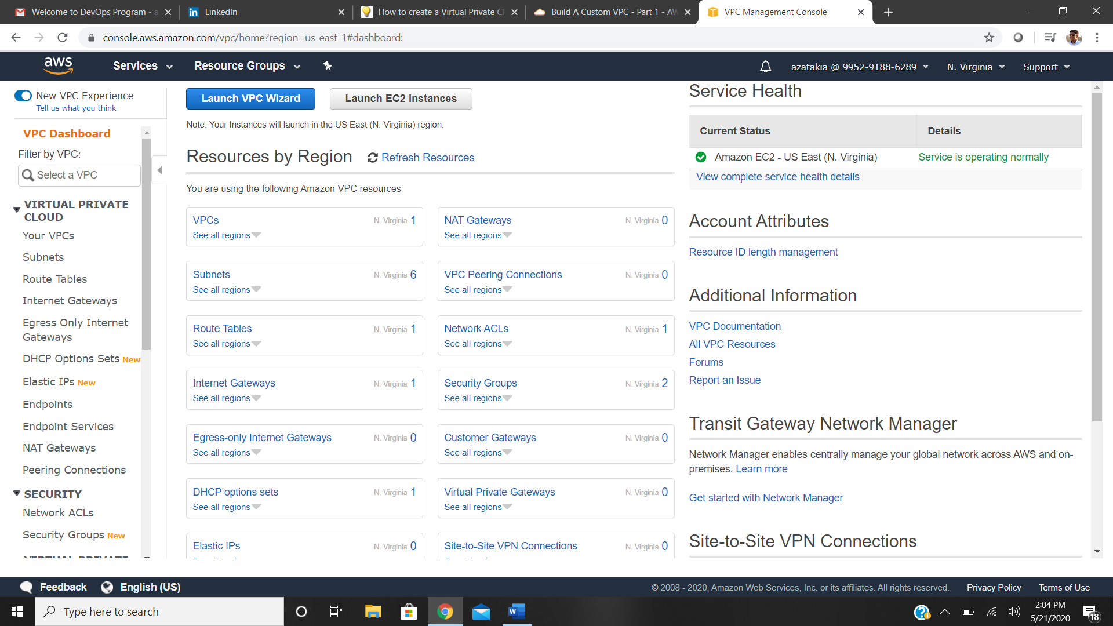

Step 2: Select Create VPC

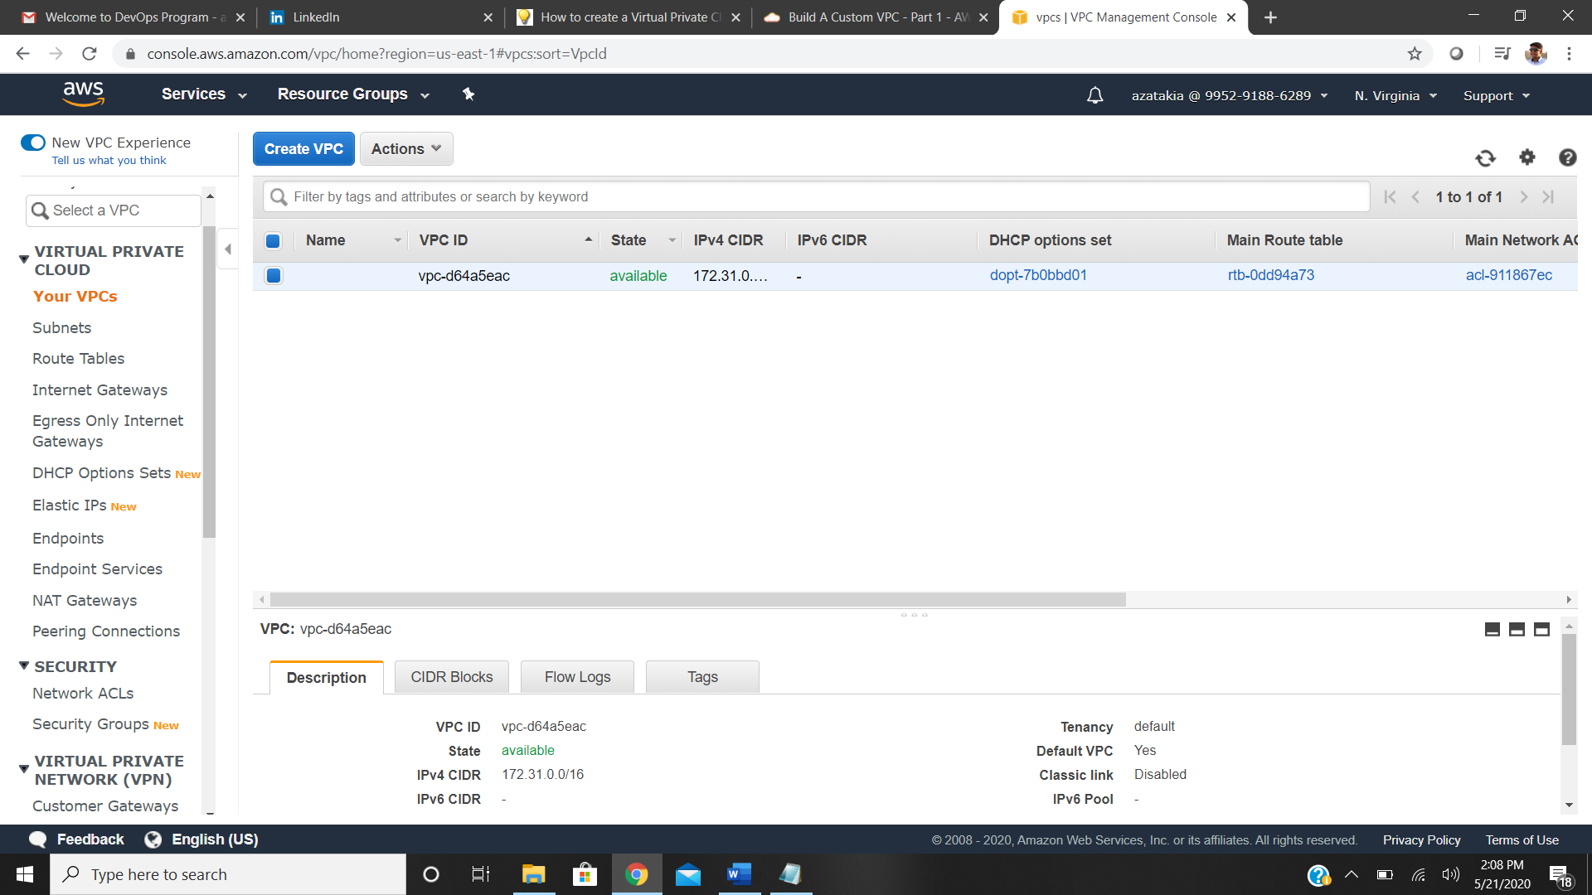

Step 3: Name your VPC; Provide the CIDR Block value, range of IPv4 addresses i.e 10.0.0.0/16 - for max number of ip range 65536; ipv6 keep it to amazon provided block; tenancy keep it default (free tier)

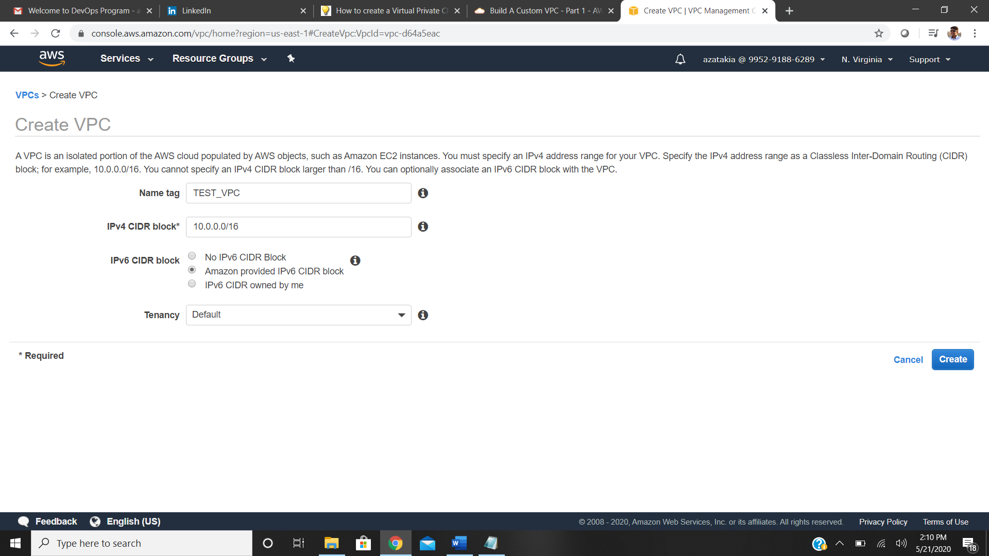

After Pressing Create there are certain resources that are created by default such as Route Table, Network access control list (NACL), Security Group. All these resources are by default and you need to create other resources too for accessing your VPC.

Step 4: Creating public Subnet in your VPC

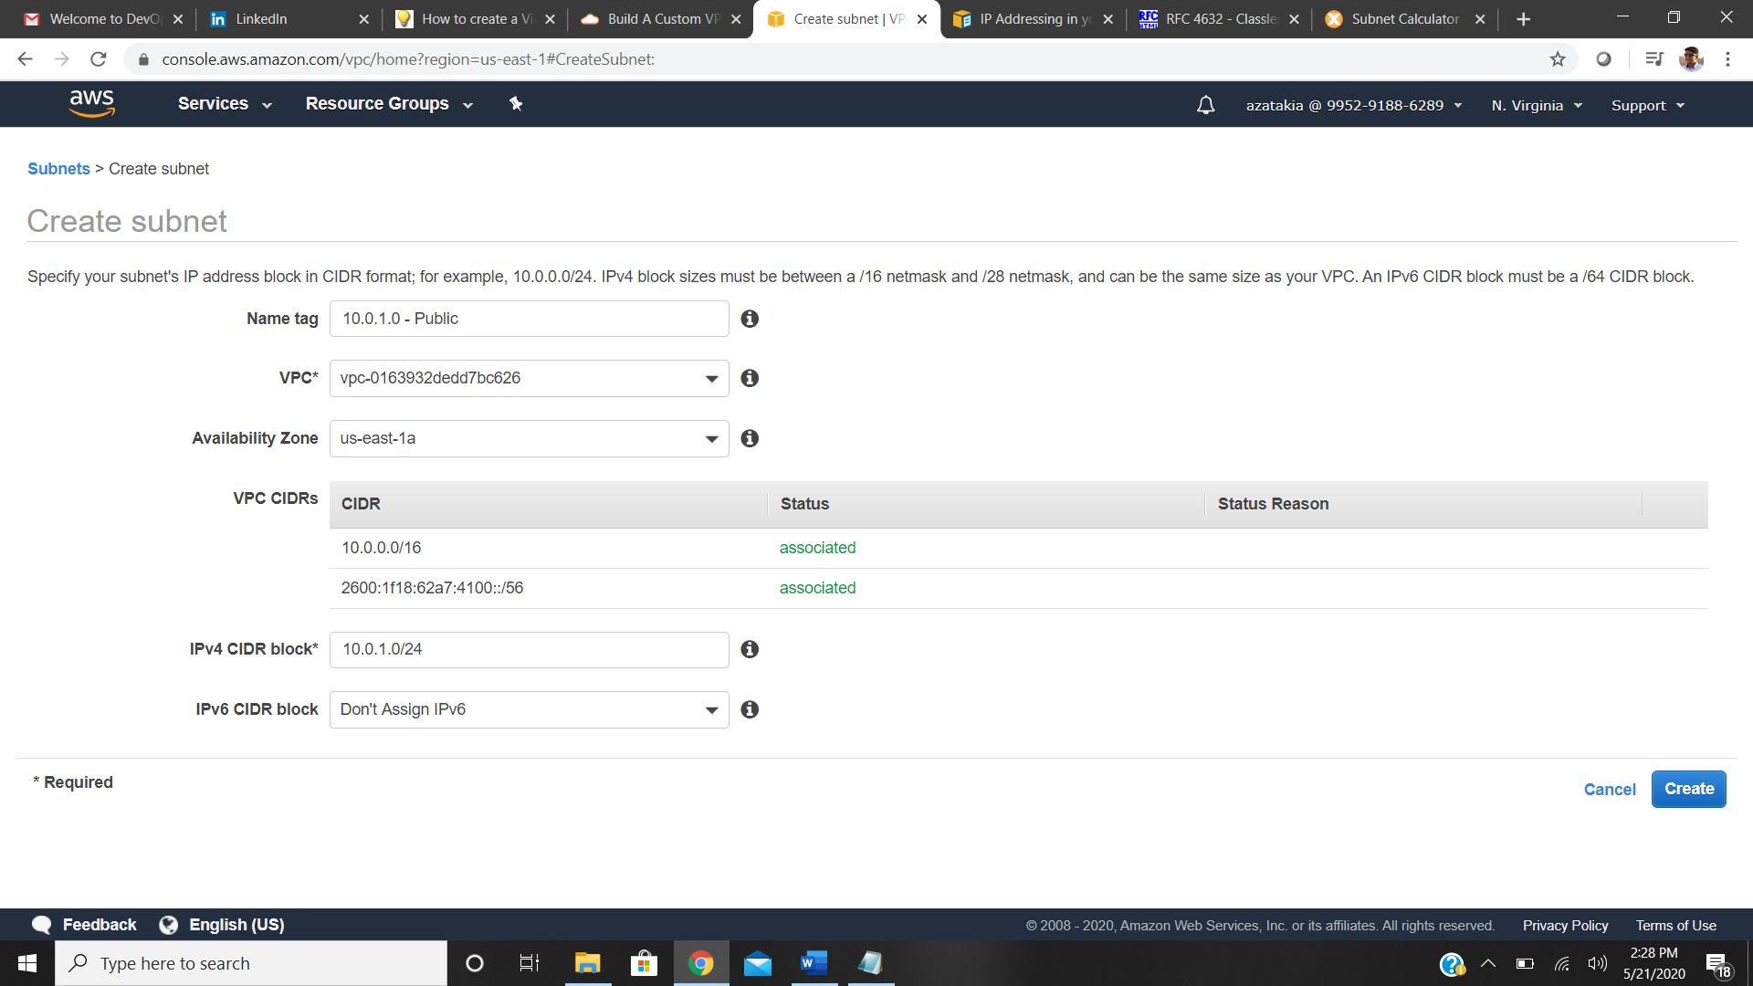

Step 5: Creating Private Subnet in Your VPC

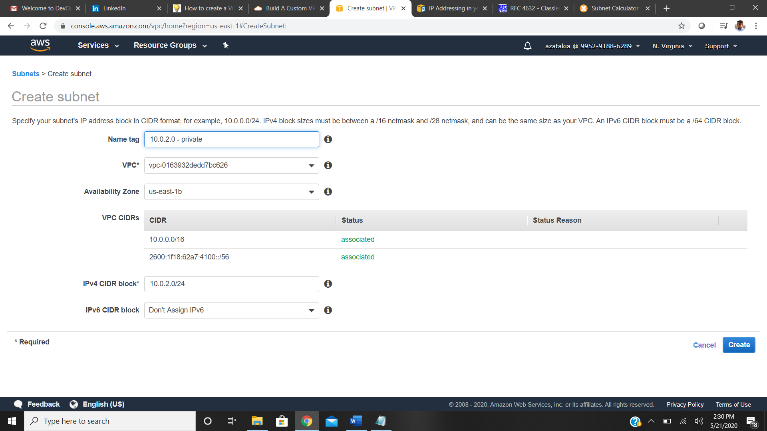

Step 6: View Of your public & private Subnet

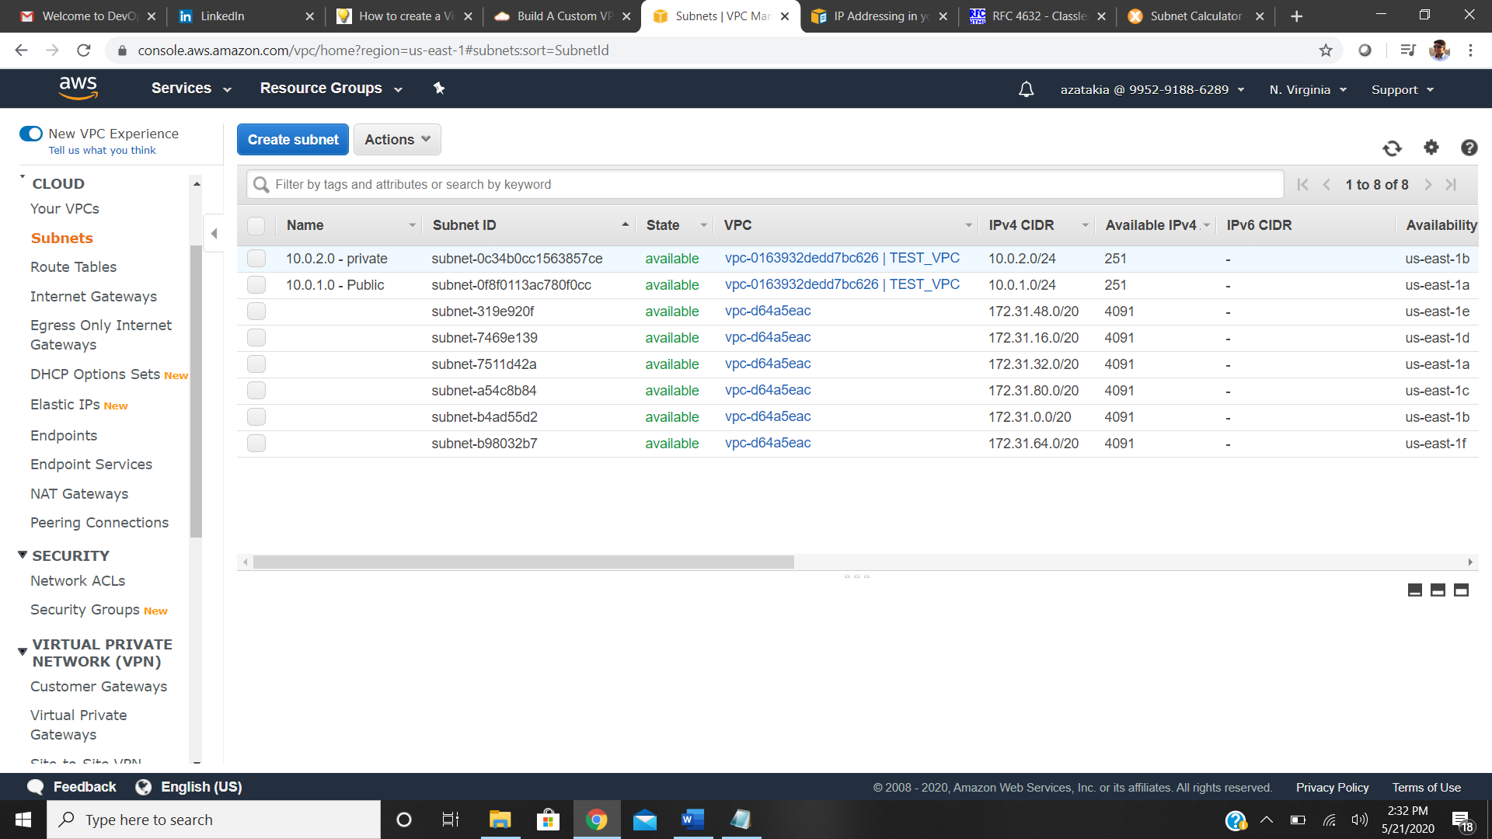

When you look at these subnets you see that auto assign public ip address id being turned off by default if you want to launch ec2 instances in public subnet then we have to turn the auto assign public IP address on. For that select the public Subnet and go to actions and then just go over to modify auto-assign IP and enable auto-assign public IPv4 .

Step 7: Turn on Auto Assign Public IPv4

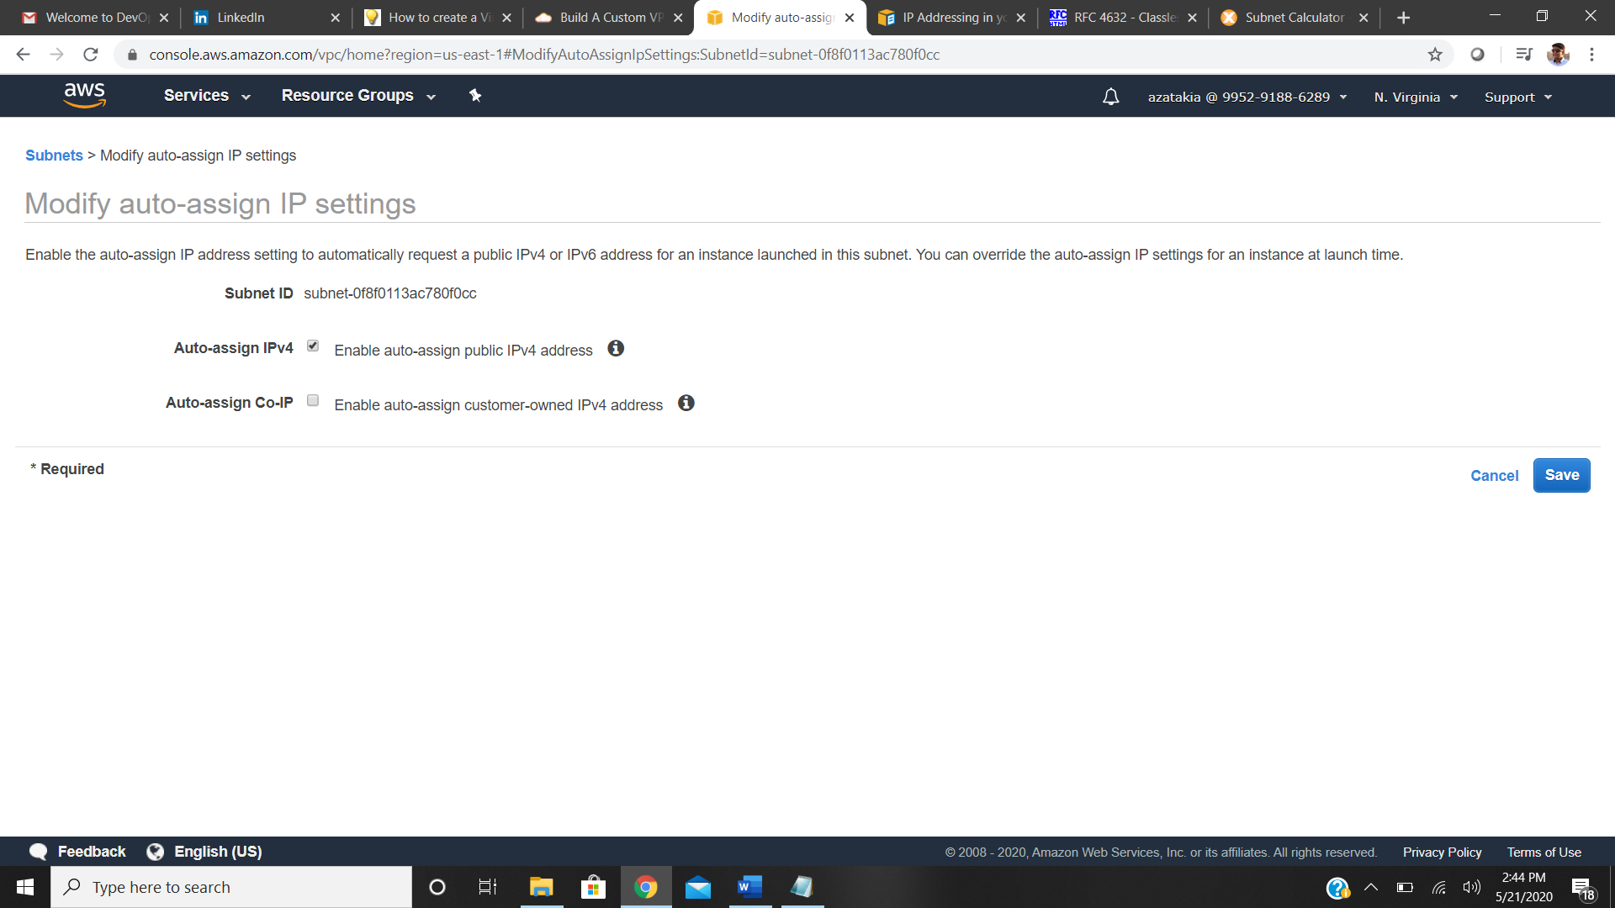

We've got our public subnet, 10.0.1.0. And we've got our private subnet, 10.0.2.0. We've got our Network ACLs, our Security Groups, our Route Table but what we're missing is a way

to get onto this VPC. So, we're going to need to add an internet gateway and then we're going to have to go in and start configuring our Route Tables.

Step 8: Creating Internet Gateway

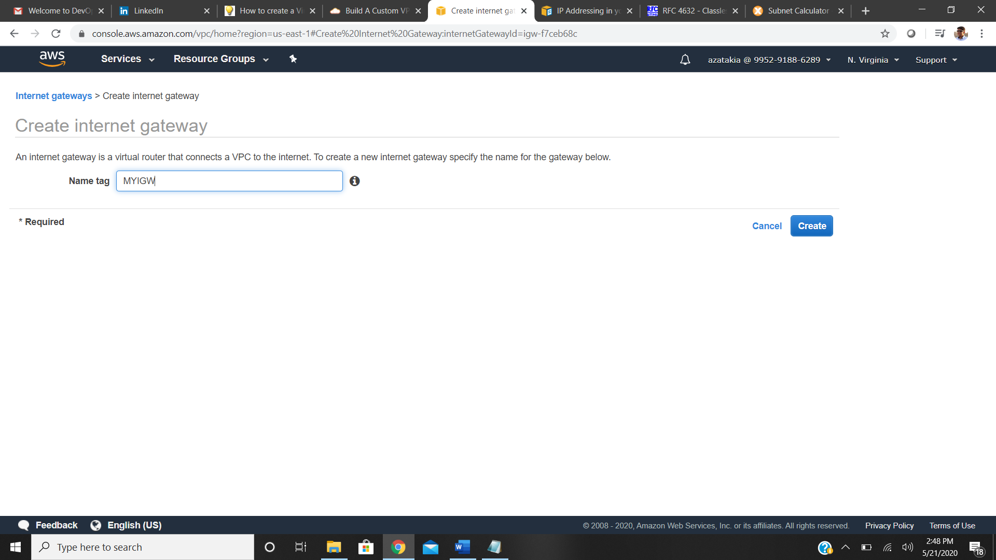

After Creating Internet Gateway We need to attach it to a VPC

Step 9: Attaching internet gateway to VPC

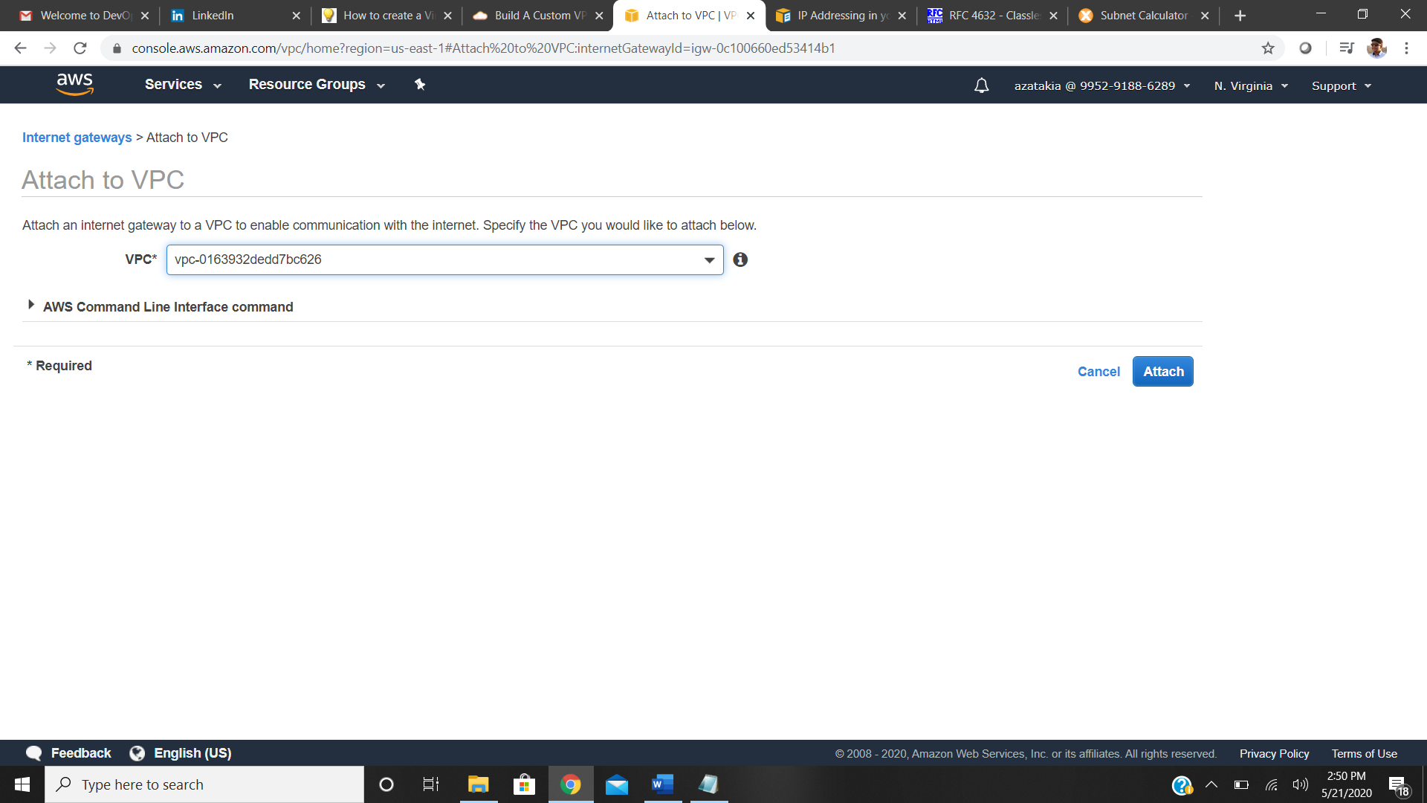

Now we have to configure our route table if we were to put a Route out to the internet in our main

Route Table, that means that any subnets that we were creating would automatically be associated

to our main Route Table. And what that would mean is that all every subnet that we create by default would be public. Now that could be a security concern, so really what we want to do is always keep our main Route Table as private. And then we have a separate Route Table for our public subnets.

Step 10: Creating a public Route table

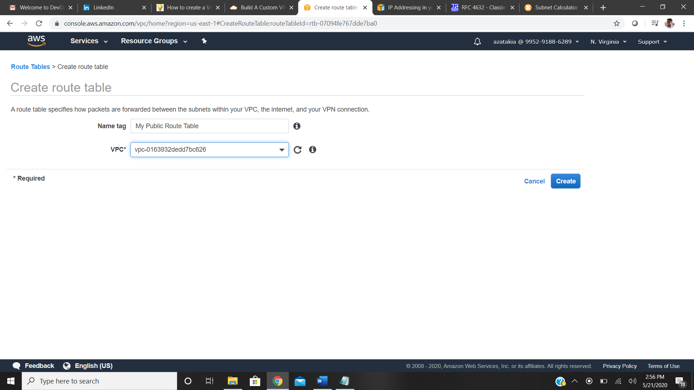

Step 11: Adding route to internet through our route table

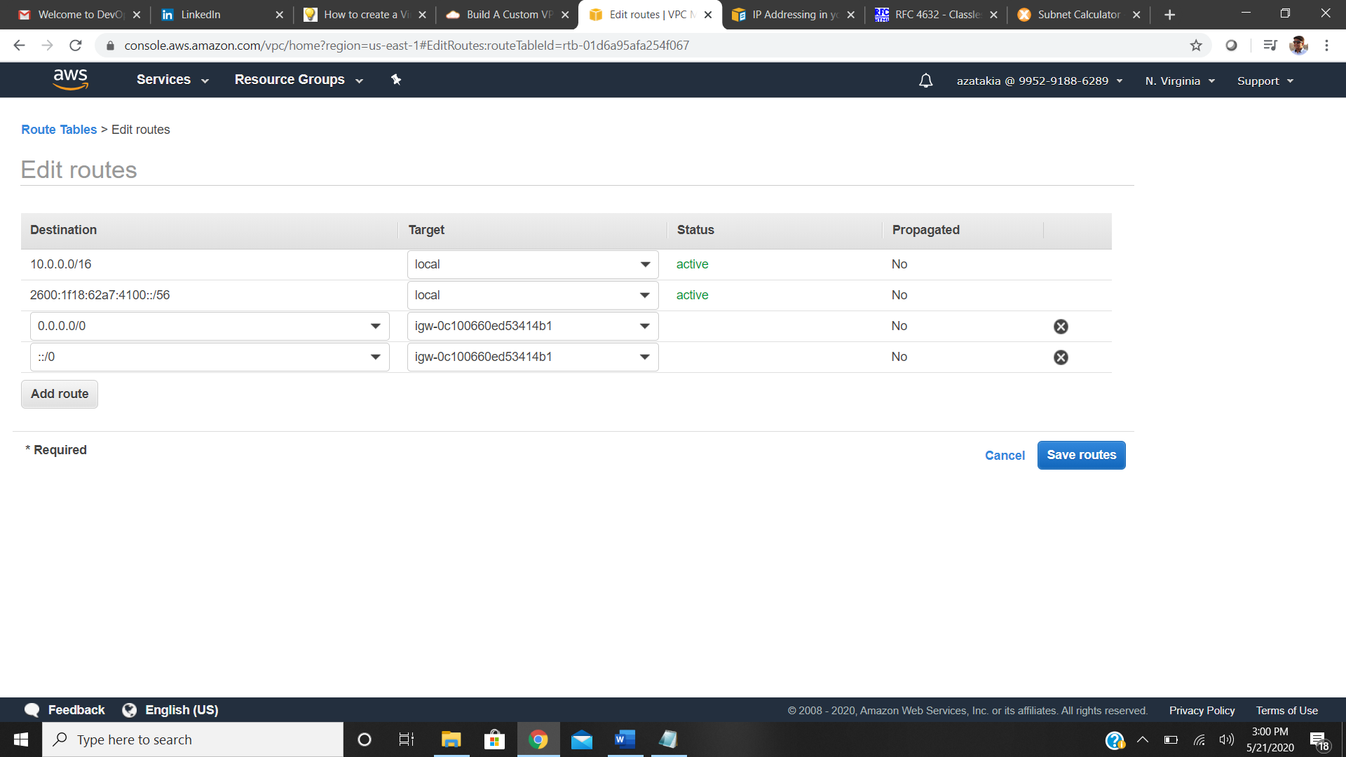

Step 12: Associating our Public subnet to our public route table

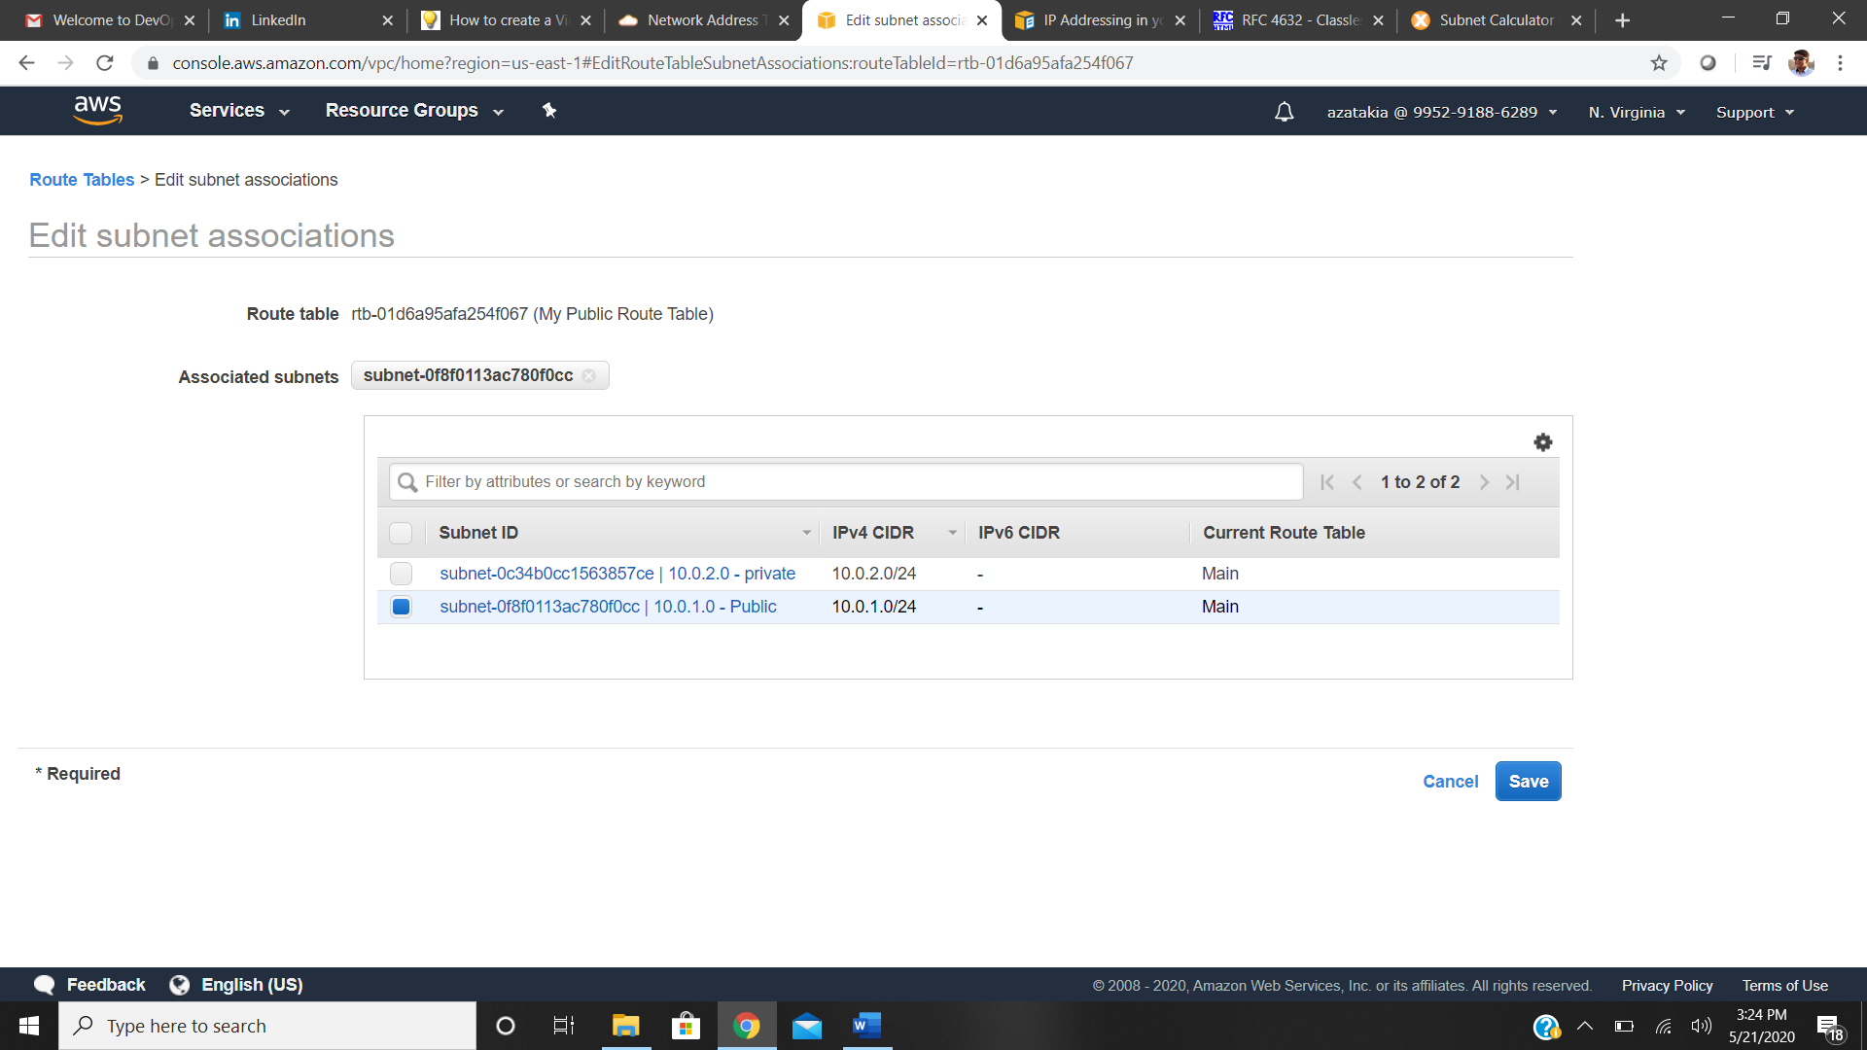

Next we are going to create a NAT gateway for our instances in private subnet so that they can interact with the internet; or query any data

Step 13: Creating NAT Gateway

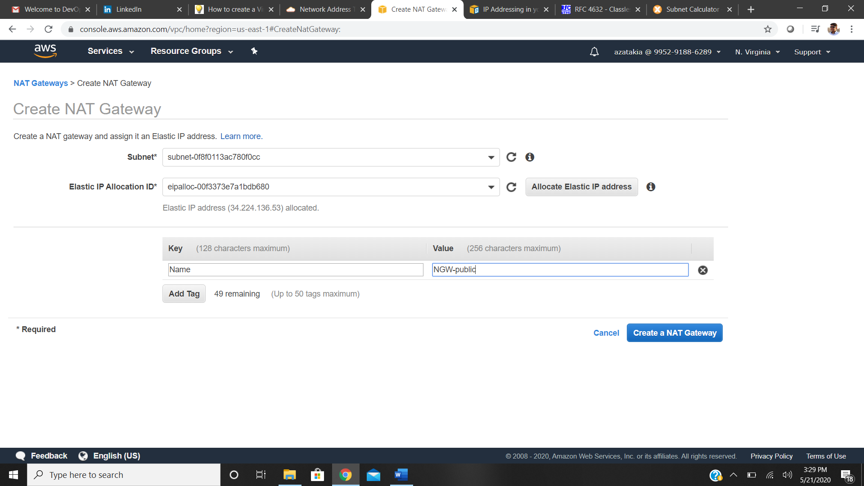

Step 14: Adding route to NAT gateway in main route table for our private instances

